DETERMINATION OF THE CHEMICAL CONSTITUENTS OF HEMIDACTYLUS FRENATUS TAIL, A NOVEL SUBSTANCE ABUSED BY YOUNG PEOPLE IN NIGERIA

IKIMI, CHARLES GERMAN^{1*} AND EKAKITIE, OFOVWE OBRUCHE²

¹Department of Medical Biochemistry, Faculty of Basic Medical Sciences, Federal University Otuoke, Bayelsa State, Nigeria. Email: ikimicg@fuotuoke.edu.ng

²Department of Human Physiology, Faculty of Basic Medical Sciences, Federal University Otuoke, Bayelsa State, Nigeria. Email: ekakitieoo@fuotuoke.edu.ng

*Corresponding author: IKIMI, C.G. Email: ikimicg@fuotuoke.edu.ng

Abstract
Background: The campaign against substance abuse shall be baseless without empirical evidence to validate such clamours. The abuse of H. frenatus tail has become prevalent among youths in Nigeria. Hence, this study is an attempt to provide primary data on the psychoactive and toxic chemical content of H. frenatus tail, in order to arrive at empirical decisions on its use.
Methods: H. frenatus tail were collected by cutting off the tails of life H. frenatus caught in buildings at the Federal University, Otuoke, Bayelsa state. Collected samples were sun dried for ten days, pulverized and then processed for analysis. The chemical constituents of the concentrated extracts of H. frenatus tail were determined with a Gas Chromatography-Mass Spectrometry (GC-MS) machine.
Results: The result showed twenty-four compounds along with their nomenclature, chemical formula, structure, molecular weight, retention time and peak area. The most abundant constituent by peak area was shown to be 9,12-Octadecadienoic acid (10.56%). The constituent with the highest retention time (21.500mins) is shown to be cyclopentanetridecanoic acid and it was also the constituent with the highest molecular weight (356Da). Identified psychoactive compounds among the discovered constituents in H. frenatus tail were 9-octadecenamide, indolizine, 2-furan-methanamine and 2- piperidinone while the toxic chemicals identified among the constituents of H. frenatus tail includes indolizine, propanenitrile, 9-Octadecenamide, oleic acid, 2-piperidinone and 2-furanmethenamine.
Conclusion: The indiscriminate unconventional use H. frenatus tail for its psychoactive properties constitute a threat to the health of the numerous young people who abuse it given its discovered harmful chemical content. If left unchecked, the current trend in substance abuse in Nigeria may lead to an increased incidence of morbidity. This information should be deployed in organized health sensitization schemes to discourage young people consuming H. frenatus tail.

1.0 Introduction
People abuse psychoactive substances for various reasons which may include curiosity and peer pressure, especially among school children and young adults; recreational purposes; unintended addiction to prescription drugs originally intended for pain relief; spiritual/religious practices or rituals; and as a means of obtaining creative inspiration [1]. Substance abuse disorders are associated with a wide range of short- term and long- term health effects. They can vary depending on the type of drug and route of administration and the individual health at large. Notwithstanding, the effects of drug abuse and dependence can be far- reaching. They have been found to adversely impact almost every organ in the human body with often irreversible deleterious effects [2].
Most commonly abused substances act by temporarily altering a person's neurochemistry, which in turn causes changes in a person's mood, cognition, perception and behaviour [2]. There are many ways in which substance use can affect the brain. Each substance has a specific action on one or more neuro transmitter or neuroreceptor in the brain. Exposure to a psychoactive substance can cause changes in the structure and function of neurons as the nervous system tries to re-establish the homeostasis disrupted by the presence of the substance. Depending on its method of action, a psychoactive substance may block the receptors on the postsynaptic neuron (dendrites), stop block reuptake or affect neurotransmitter synthesis in the presynaptic neuron [3].
There are reports that H. frenatus (wall gecko) tails contain intoxication inducing substances and this explains their intake/abuse by some young people [4]. The consumption of H. frenatus causes instant intoxication judging from observation of its abusers [5]. The intoxicating effects of the mixture of H. frenatus tail is believed to be 50% higher than marijuana and cocaine [6]. The exact cause or substance responsible for the psychoactive effects of this mixture is not yet known. The users are prone to have to some clinical syndromes. The mixture causes addiction as the craving is usually unbearable resulting in nausea, itching of the throat, gums and several body parts and mild trembling. It also causes sedation in the user that lasts at least 10hours [7]. A rare case of the abuse of its mixture by a prisoner with cannabis dependence was contained in an African literature. The report has it that the prisoner shifted to its use during the periods of non-availability of cannabis, and it has since gained popularity as a potent alternative to the regulated cannabis [8].
H. frenatus is a gecko that is also known as pacific house gecko, the Asian house gecko, wall gecko, house lizard or moon lizard and is in the family of the Gekkonidae. Most geckos are nocturnal, hiding during the day and foraging for insects at night. They can be seen climbing walls of the house and other buildings in search of insect directed to porchlights and is immediately recognizable by its characteristic chirps. They grow to a length of between 75-150mm (3-6in) and living for about 5 years. These small geckos are non-venomous and not harmful to humans [9]. The body is flattened and the toe pads are divided and the first digit is much smaller than the others, also, the tail has enlarged ventral plates and a denticulate margin. H. frenatus are grayish, pinkish, or pale brown with darker flecks. Other characters include divided lamella; dorsum and venter light in coloration, sometimes semi- transparent; a light line through eye; dark lateral stripe may be present. H. frenatus has a very distinctive” chuck, chuck, chuck” call which is commonly emitted at dusk and dawn. This call is one of the key indicators that house geckos are present in a particular area. H. frenatus exists in Southeast Asia and the Indo-Australia archipelago, the Philippines, Taiwan, and much of Micronesia, Melanesia, and Polynesia. H. frenatus are found in Australia, Africa, Mexico, the United States and in several parts of the world. Medium to large geckos may bite if distressed. However, their bite is gentle and will not pierce skin [10]. Modes of abuse/intake of H. frenatus tail are by inhalation, smoking and drinking a cocktail mixture of it with other substances [4,6].
Revealing the psychoactive and toxic chemical content of H. frenatus tail is the focus of this study. This is because H. frenatus tail is now being seriously being abused by young people due to its psychoactive effects. Therefore, determining its chemical constituents will empirically inform decisions on its use. Perhaps, the reason this substance of which very little is known is widely abused may be because it is easily accessible to abusers as it is abundant in the environment; it is easily acquired because it is not expensive; the effects of abusing it have not been explicated as a result of little or no research; and its abuse is not monitored by law enforcement agencies since it is not a regulated substance. Meanwhile, there is serious suspicion that it may have a great toxic potential due to the efficacy with which it induces intoxication on abusers [11].
2.0 Materials/methods
2.1 Study area
Sample collection was conducted at the Federal University, Otuoke, Ogbia Local Government Area, Bayelsa state, Nigeria, while the Gas Chromatography coupled to Mass Spectrometry (GC-MS) analysis was carried out at the National Agency for Food and Drug Administration and Control (NAFDAC) South-East Zonal Area Laboratory, Agulu, Anambra State. Bayelsa State is located in the Oil-Rich Niger Delta region of Southern Nigeria, with geographical coordinates of 4°55'N and 6°15'E. The region has a tropical monsoon climate, with temperature fluctuations between 71°F and 87°F, alternating between a wet rainy season and a cloudy dry season [12]. Anambra State is located in the South-East geo-political region of Nigeria. Its geographical coordinates are 6°20'N and 7°00'E. It has a savanna climate with an average yearly temperature of 84.18°F and it is one of the most populated states in Nigeria [13].

2.2 Collection of samples
The tail of H. frenatus were collected by cutting off the tails of life H. frenatus caught in cracks and walls of houses in Otuoke, Ogbia Local Government Area of Bayelsa state, Nigeria, using sterile razor blades and placed in polyethene bags.
2.3 Preparation of Samples
The collected H. frenatus tails were spread on a polyethylene film and sun-dried between 9am and 4pm for a period 10days. The dried H. frenatus tail was pulverized with the use of laboratory hand mill (Corona) to obtain a fine particle size of BS/72 mesh. The mettler balance was switched on and the beaker was placed on the top of scale pan with the meter reading zero. A 50g aliquot amount of the pulverized sample was weighed and transferred into a bottle and labeled. Then 200ml of ethanol spectrosol was added to the sample. The set up was preserved for 48hrs at room temperature in a dark cupboard. The sample was then filtered with a sintered glass funnel under pressure and the filtrate was received in a 500ml conical flask. The residue was eluted with additional 50ml of the solvent and the combined filtrate was 225ml. The extract was light ash in colour. On a water bath preset at 50◦C was placed an aliquot 50ml of the extract contained in a 100ml beaker to dry. Drying was done till the residual volume of the extract was 25ml (volume halved). The concentrated extract was then poured into a 50ml cleaned and dried glass sample bottle with a firm stopper and kept for gas chromatography coupled with mass spectrometry (GC-MS) analysis.

2.4 Analysis of sample
The chemical constituents of the concentrated extracts of H. frenatus tail were determined with a Gas Chromatography-Mass Spectrometry (GC-MS) machine as reported by Sparkman et al. [14]. Briefly, the GC-MS is composed of two major parts: the gas chromatograph and the mass spectrometer. The gas chromatograph utilizes a capillary column which depends on the column's dimensions (length, diameter, film thickness) as well as the phase properties (e.g., 5% phenyl polysiloxane). The difference in the chemical properties between different molecules in a mixture and their relative affinity for the stationary phase of the column will promote separation of the molecules as the sample travels the length of the column. The molecules are retained by the column and then elute (come off) from the column at different times (called the retention time), and this allows the mass spectrometer downstream to capture, ionize, accelerate, deflect, and detect the ionized molecules separately. The mass spectrometer does this by breaking each molecule into ionized fragments and detecting these fragments using their mass-to-charge ratio.
The machine was switched on. With the use of a syringe, samples were injected into the sample pot or aspirator pot of the machine. This was followed by opening of the inlet tap for the inert gas, followed by the heater to raise the temperature to about 230ºC in inert atmosphere of stable aerosol. The chromatograph commenced and fractions obtained were fed automatically to the mass spectrograph to obtain the results and the associated hints. The GC-MS analysis was carried out on a GC clarus 500 perkin Elmer system comprising of a AOC-20i auto-sample and a gas chromatography interfaced to a mass spectrometer (GC-MS) instrument employing the following conditions: column Elite- 1 fused silica capillary column (30× 0.25 mm ID × 1µM df, composed of 100% dimethylpoyl diloxane), operating in electron impact mode at 70ev: helium (99.999%) was used as a carrier gas at a constant flow of 1ml/ml and an injection volume of 0.5µL was employed (split ratio of 10.1) injector temperature 230ºC, ion-source temperature of 280ºC. The oven temperature was programmed from 110ºC/min, to 200ºC, then 5ºC/min to 280ºC, ending with a (min isothermal at 280ºC. Mass Spectra were taken at 70ev; a scan interval 0.5s and fragments from 40 to 450Da. Total GC running time was 28min.
3.0 Results
The result of GC-MS analysis revealed 24 compounds which are listed in table 1, along with their nomenclature, chemical formula, structure, molecular weight, retention time and peak area.

Table 1: Chemical constituents of H. frenatus tail
HIT | NOMENCLATURE & FORMULA | STRUCTURE | MOLECULAR WEIGHT (Da) | RETENTION TIME (Mins) | PEAK AREA  (%)
1  2  3  4  5 | N-[2-Cyanoethyl]-2-mercapto-2-methylpropanamide  (C₇H₁₄N₂S)  Cyclohexanol (C₉H₁₈O)  4-Methyl-2-heptyn-4-ol (C₈H₁₄O)  Propanenitrile (C₁₅H₃₀N₂)  Chimilether (C₂₁H₄₄O₃) | 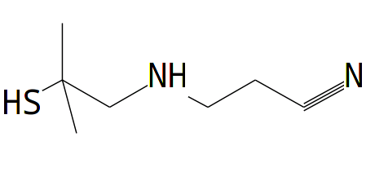  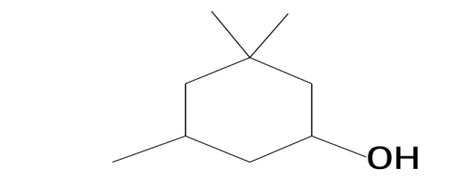  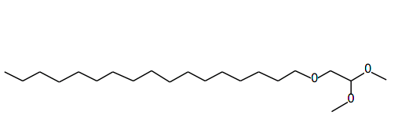  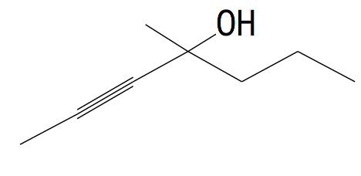  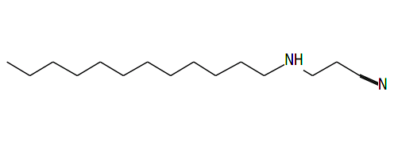 | 158  142  126  238  344 | 6.617  7.375  8.083  8.158  9.550 | 0.18  0.18  0.28  0.56  0.12

HIT | NOMENCLATURE & FORMULA | STRUCTURE | MOLECULAR WEIGHT (Da) | RETENTION TIME (Mins) | PEAK AREA  (%)
6  7  8  9  10 | 2-Piperidinone (C₅H₉NO)  2-Furanmethanamine (C₁₀H₁₉NO₂)  2,4(1H,3H)-Pyrimidinedione (C₄H₆N₂O₂)  Indolizine (C₈H₇N)  Oleic Acid (C₁₈H₃₄O₂) | 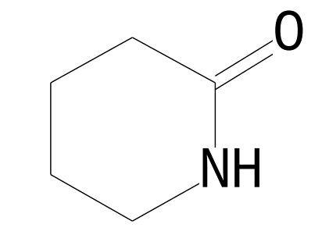  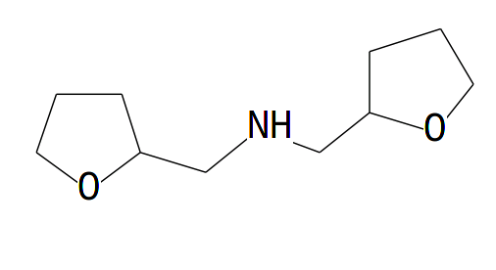  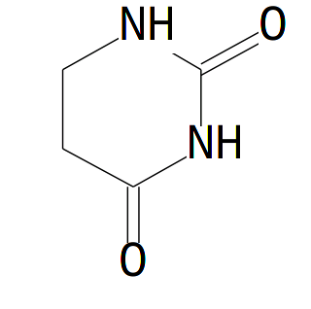  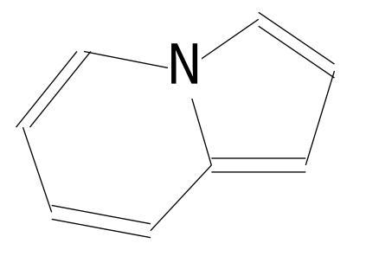  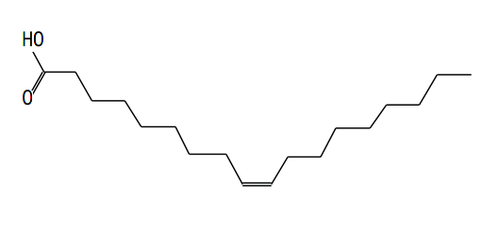 | 99  185  114  117  282 | 9.925  10.950  11.117  11.250  15.792 | 1.99  0.17  0.23  0.15  0.14

HIT | NOMENCLATURE & FORMULA | STRUCTURE | MOLECULAR WEIGHT (Da) | RETENTION TIME (Mins) | Peak Area  (%)
11  12  13  14  15  16  17  18 | 2- Oxecanone (C₁₀H₁₈O₂)  Dodecanoic acid (C₁₃H₂₆O₂)  9-Octadecenoic acid acid (C₂₁H₄₀O₄)  Cyclopentanetridecanoic acid (C₁₉H₃₆O₂₎  17- Octadecynoic acid  (C₁₈H₃₂O₂)  11-Dodecen-2-one (C₁₂H₂₂O)  9,9- Dimethoxybicyclo  (C₁₁H₁₆O₄)  9- Octadecenamide (C18H35NO) | 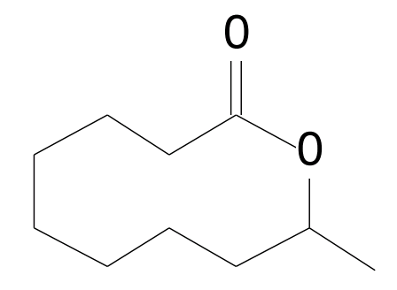  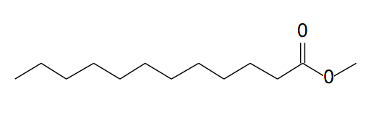  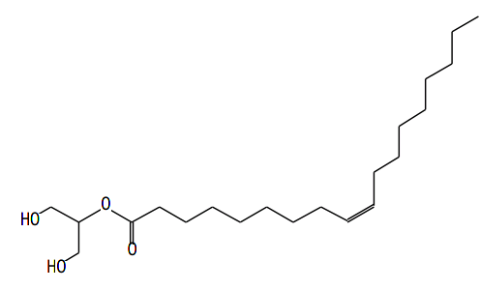  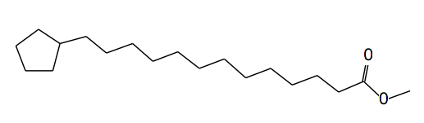  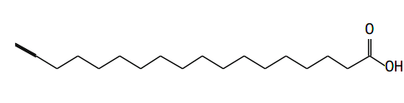  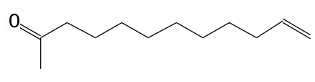  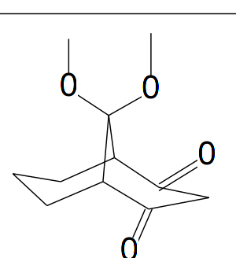  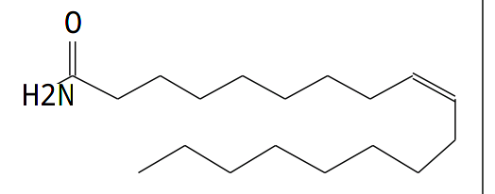 | 170  214  356  296  280  182  212  281 | 12.317  13.583  21.500  15.342  19.758  20.083  18.092  19.650 | 0.76  0.34  2.87  1.33  1.67  0.72  0.41  2.35

HIT | NOMENCLATURE & FORMULA | STRUCTURE | MOLECULAR WEIGHT (Da) | RETENTION TIME (Mins) | Peak Area  (%)
19  20  21  22  23  24 | n-hexadecanoic acid (C₁₆H₃₂O₂)  7- hexadecenoic acid (C₁₇H₃₂O₂)  9,12-Octadecadienoic acid (C₁₉H₃₄O₂)  8-methyl-6- nonenamide (C10H19NO)  Hexadecanoic acid  (C₁₈H₃₆O₂)  11-octadecenoic acid (C₁₉H₃₆O₂) | 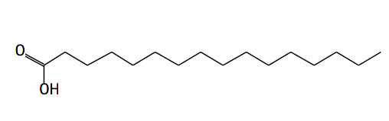  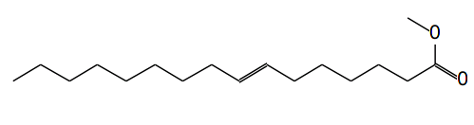  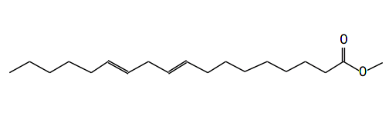  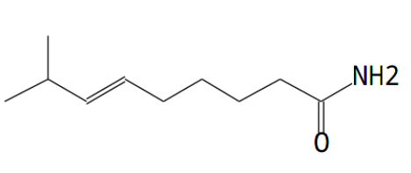  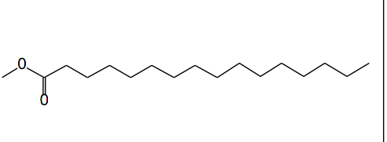  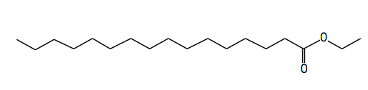 | 256  268  294  169  284  296 | 17.283  16.700  17.975  18.683  14.233  18.008 | 5.82  0.29  10.56  7.57  2.86  5.60

4.0 Discussion
The spate at which H. frenatus tail is being used unconventionally necessitated an investigation of its constituents [15]. From the GC-MS results of H. frenatus tail, the most abundant constituent by peak area was shown to be 9,12-Octadecadienoic acid (10.56%). The constituent with the highest retention time (21.500mins) is shown to be cyclopentanetridecanoic acid and it is also the constituent with the highest molecular weight (356Da). Identified psychoactive compounds among the discovered constituents in H. frenatus tail were 9-octadecenamide, indolizine, 2-furan-methanamine and 2- piperidinone. More so, toxic chemicals identified as constituents of H. frenatus tail includes indolizine, propanenitrile, 9-Octadecenamide, oleic acid, 2-piperidinone and 2-furan methenamine.
Indolizines are potent disruptors of protein synthesis. They inhibit enzyme activity and acts as calcium entry blockers in cardiovascular activity Indolizines are also a histamine (H₃) receptor antagonist. The derivatives of indolizine were found to exhibit cytotoxic and central nervous system depressant activity [16,17]. Propanenitrile causes sore throat, chest tightness, shortness of breath, unconsciousness, respiratory and cardiac arrest. It induces structural changes in the cells of the duodenum and stomach. It is also associated with bringing about ulcerogenic effect [18]. Increased oleic acid level in the membranes of red blood cell have been associated with increased risk of breast cancer [19].
9-Octadecenamide has been shown to accumulate in the cerebrospinal fluid and it causes drowsiness [20]. It has also been implicated in the aetiology of cannabinoid-regulated depression [21]. 2-piperidinone, a derivative of piperidine, classified as a lactam. It is a known psychotropic agent with cytotoxic potentials [22,23,24]. 2-furan methenamine are and most furan containing chemicals are reported to be very to be very harmful. They are hepatotoxic and carcinogenic [25,26]. The findings of this study make it empirical to prognosticate that the now rampant act of the unconventional use of H. frenatus tail by youths in Nigeria for its inebriating effects shall adversely impact on the health of its abusers as validated by a recent study on the impact of chemical mixtures on immunological indices [27].
5.0 Conclusion
The indiscriminate unconventional use H. frenatus tail for its psychoactive properties constitute a threat to the health of the numerous young people who abuse it given its discovered harmful chemical content. If left unchecked, the current trend in substance abuse in Nigeria may lead to an increased incidence of morbidity. This information should be deployed in organized health sensitization schemes to discourage young people consuming H. frenatus tail.
REFERENCES
[1]. Glynn, T.J. (2018). From family to peer: transitions of influence among drug- using youth. Journal of youth and adolescence,10:363-383

[2]. Siegel, A. & Ronald, K. (2015). Intoxication: the universal Drive for Minding- Altering Substances. Parkstreet press, 60:99-108

[3]. Lix, O. & Pearce, R.A. (2015). Effects of halothane on GABA receptor kinetic: evidence for slowed agonist unbinding. journal, 20(3): 899-907

[4]. Garg, M., Sidhu, B.S. & Raj, R. (2014). Addiction to lizard. Indian journal psychiatry 56(2): 244-249

[5]. Aich, T., Saha, I., Ram, D., Ranjan, S. & Subedi, S. (2015). A comparative study on 136 opioid abusers in India and Nepal. Journal of Psychiatrists’ Association of Nepal (2):11–17.

[6]. Varghese, S.T., Balhara, Y. & Mondal, A. (2006). Unconventional substances of abuse: scorpions and lizards. Journal Postgraduate Medicine, 52:325-6
[7]. Sarkhel, S., Praharaj, S. K. & Sinha, V. K. (2011). Does lizard tail lacing heighten cannabis addiction? The American Journal on Addictions, 20:181–181

[8]. Malhatra, C. (2017). Drug abuse among juveniles in conflict with law, Journal of Pediatrics 74(3): 352-356

[9]. Case, T.J., Bolger, D.T. & Petren, K. (2006). Invasions and competitive displacement among house geckos in the tropical pacific. Ecology, 75(2): 464-477

[10]. Cameron, S.F., Wynn, M.L. & Wilson, R.S. (2013). Sex-specific trade-offs and compensatory mechanisms: bite force and sprint speed pose conflicting demands on the design of geckos (Hemidactylus frenatus). The Journal of Experimental Biology, 216 (0) 3781-3789

[11]. Ikimi, C.G. & Addy, P.S. (2024). Effects of a mixture of methylated spirit and carbonated cola drink (a novel substance abused by Nigerian youths) on the lipid profile of Wistar rats. International journal of health and pharmaceutical research (international institute of research and academic development), Vol. 9 (3): 83 – 92.

[12]. Agoro, E.S., Ikimi, C.G. and Edidiong, T. (2021). The use of vitreous renal chemistries in the discrimination of postmortem fresh water drowning. Toxicology research and application, Vol. 5: 1-6.
[13]. Ezenwa-Ohaeto, N. (2013). Sociolinguistic import of name-clipping among Omambala cultural zone in Anambra State. Creative Artist: A Journal of Theatre and Media Studies 7(2): 111 – 128.
[14]. Sparkman, O.D., Penton, Z.E. & Kitson, F.G. (2011). Gas chromatography and mass spectrometry: a practical guide, second edition, Academic press publishers,15-20.

[15]. Sanggaard, K.W., Danielsen, C.C., Wogensen, L., Vinding, M.S., Rydtoft, L.M., Mortensen, M.B., Karring, H., Nielsen, N.C., Wang, T., Thogersen, I.B., & Enghild, J.J. (2012). Unique structural features facilitate lizard tail autotomy. PLoS ONE 7(12): e51803

[16]. Juang, S.S., Chang, M., Wang, L.F. & Han, J.L. (2005). Environmentally benign one-pot synthesis and antimicrobial activity of 1-methyl-2; 6-diary/piperidine-4-ones. Tetrahedron, 61:1693-1697

[17]. Singh, G.S. & Mmatli, E.E. (2011). Recent progress in synthesis and bioactivity studies of indolizines. European journal medicinal chemistry, 46: 5237-5257

[18]. Synder, R. (2005). Ethel Browning’s toxicity and metabolism of industrial solvent. Elsevier publishers, 2: 356-360

[19]. Pala, V., Krogh, V., Multi, P., Chajes, V., Riboli, E., Micheli, A., Sieri, S., Saadation, M. & Bernno, F. (2002). Erythrocyte membrane fatty acids and subsequent breast cancer; prospective Italian study. Journal of the national cancer institute, 93(14): 1088-1090

[20]. Mckinney, M. & Cravatt, B.F (2005). Structure and function of fatty acid Amide Hydrolase. Annual Review of Biochemistry. 74(1): 411-432

[21]. Raphael, M., Ester, F., Lumir, H., Tzviel, S., Tiziana, B., Vincenzo, M., Micheal, B. & Zvi, V. (1997). Anandamide may mediate sleep induction”. Nature, 389 (6646): 25-26

[22]. Trincado, M., Kuhlein, K. & Grutzmacher, H. (2011). Metal-Ligand Cooperation in the Catalytic Dehydrogenative Coupling (DHC) of Polyalcohols to Carboxylic Acid Derivatives, Chem. Eur. J., 17(42):11905-11913

[23]. Pingen, D. & Vogt, D. (2014). “Amino-Alcohol Cyclization: Selective Synthesis of Lactams and Cyclic Amines from Amino-Alcohols”, Catal. Sci. Technol., 4:47-52

[24]. Al-Bahadily, D.C.H., Shari, H.F., Najim, M.A.A. & Al-Salman, H.N.K. (2019). Clinical pathogenic isolated antimicrobial activity of the compound 2-Piperidinone, N-[4-Bromo-n-butyl] extracted from pomegranate peels, Asian Journal of Pharmaceutics, 13(1): 46-53

[25]. Kuroda, K., Ishii, Y., Takasu, S., Matsushita, K., Kijima, A., Nohmi, T. & Umemura, T. (2022). Toxicity, genotoxicity, and carcinogenicity of 2-methylfuran in a 90-day comprehensive toxicity study in gpt delta rats. Food Chem Toxicol.168:113365

[26]. Tian, M., Peng, Y. & Zheng, J. (2022). Metabolic Activation and Hepatotoxicity of Furan-Containing Compounds. Drug Metab Dispos; 50(5):655-670

[27]. Ikimi, C.G., Adias, T.C. and Agoro, E.S. (2024). Effects of a mixture of methylated spirit and carbonated cola drink (a novel substance abused by Nigerian youths) on kidney function and haematological parameters in Wistar rats. Otuoke Journal of Medical Laboratory Science, Vol. 1 (1): 119 – 128.

Acknowledgment
The supervisory oversight role of Prof. M.M. Etukudo of the Department of Biology, Faculty of Science, Federal University Otuoke, Bayelsa State in the course of this study is greatly acknowledged.
Authors contributions
Dr. C.G. Ikimi conceptualized the work, did the laboratory analysis and wrote the manuscript. Dr. O.O. Ekakitie conducted the sample collection and processing. All authors read and approved the manuscript.

Ethical Approval
Ethical clearance was obtained from the animal research ethics committee of the Department of Medical Biochemistry, Faculty of Basic Medical Sciences, Federal University Otuoke, Bayelsa State.
Conflict of interest
The authors declared no conflict of interests.
Funding
The authors declared no source of external funding.
Availability of data and materials
See appendix

Appendix
Chromatogram of H. frenatus tail
