Microdesmis puberula HOOK F. EX. PLANCH (PANDACEAE): A PHYTOPHARMCOGNOSTIC STUDY
Imaobong, I. Etukudoh, Romanus A. Umoh, Uwemedimoh F. Umoh, Imoh, I. Johnny and Nsima A. Andy
Department of Pharmacognosy and Natural Medicine, Faculty of Pharmacy, University of Uyo, Nigeria.
Corresponding author: Email: romanusumoh@uniuyo.edu.ng; Phone: +2348028957060 Orcid Id: 0009-0002-0661-6116

ABSTRACT
Background: The stem bark, root and leaf of Microdesmis puberula Hook. F. ex. Planch (Pandaceae) is used to treat stomach ache, burns, circumcision wounds, abscesses and sores from gonorrhea. This study aimed at evaluating the pharmacognostic features of the leaf and stem of M. puberula using quality control parameters. Leaves and stems were collected, air-dried, pulverized and stored in a clean glass container.
Methods: Methods used were microscopy, micromeritic properties, chemomicroscopy, moisture content, ash values, extractive values and fluorescence analysis using standard procedures.
Results: Microscopic features as irregular epidermal cell shape and undulate anticlinal wall pattern were recorded on both surfaces. Hypostomatic distribution of stomata with anomocytic and anisocytic stomata as well as stomatal index of 15.1 % on the abaxial surface were recorded. The stem powder had a better flow rate than the leaf powder. Chemomicroscopy revealed the presence of cellulose, mucilage, oil and starch grain in both leaf and stem. Moisture contents, total ash values, acid-insoluble ash values and water-soluble ash values for the leaf and stem were (89.3 and 87.6 % ^{w}/_{w}), (5.41 and 2.41 % ^{w}/_{w}), (1.92 ± 0.00 % ^{w}/_{w}) , (0.83 ± 0.00 % ^{w}/_{w} ), (1.17 ± 0.00% ^{w}/_{w}) and (0.42 ± 0.00 % ^{w}/_{w} ) respectively. Water had the highest solubility (3.75 %) of the leaf constituent in water.
Conclusion: The results obtained will be useful in the compilation of the monograph of M. puberula for proper identification and authentication.
KEYWORDS : Phytopharmacognostic, Microdesmis puberula, Micromeritic, Chemomicroscopy, Hausner ratio and Carr’s index
1. INTRODUCTION
Microdesmis is a genus of the plant family Pandaceae. It is native to tropical Africa, China and Southwest Asia. It grows in forest and fallow land at elevations from sea level up to 1,100 metres. It includes species such as M. afrodecandra, M. camerunensis M. caseariifolia, M. haumaniana, M. kasalensis, M. keayana, M. klainei, M. magallanensis, M. pieslotiana and M. yafungana. The stem bark, leaf and root of M. puberula have numerous medicinal uses throughout the distribution area of M. puberula. Leaf sap or crushed and burnt twigs and roots are applied to snakebites or to scarifications. Leaf sap sometimes together with twig sap, is commonly taken orally or applied as an enema to treat diarrhoea. It has a rather mild action and thus prescribed for pregnant women and young children [1]. Leaf and stem sap or leaf or stem infusion is also applied externally to treat skin problems such as eczema, scabies, burns, circumcision wounds, abscesses and sores from gonorrhea [2].

Classification of M. puberula According to APG (Angiosperm Phylogeny
Group) [3]
Kingdom - Plantae
Clade - Tracheophytes
Clade - Angiosperms
Clade - Eudicots
Clade - Rosids
Order - Malpighiales
Family - Pandaceae
Genus - Microdesmis
Species - M. puberula Hook. f. ex. Planch

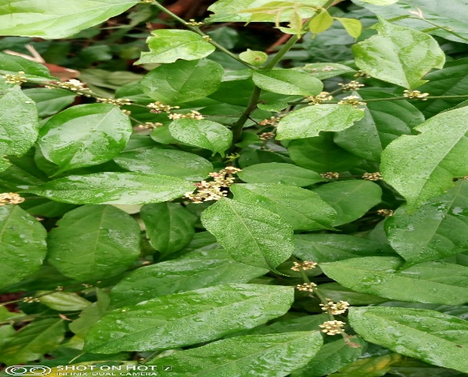
Microdesmis puberula plant in its natural habitat
Local names: Ntabid in Ibibio, Mkpiri or Mbugbo in Igbo and Idiapata in Yoruba.

2. MATERIALS AND METHODS
2.1 Collection and Identification of Plant
The plant M. puberula from the family Pandaceae was collected from the wild in the forest in Nsukara Offot village, Uyo Local Government Area of Akwa Ibom State. It was identified by Dr. Imoh Johnny in the Faculty of Pharmacy, University of Uyo. Voucher specimen was deposited in the Department of Pharmacognosy herbarium with the identification number UUPH 57(a).

2.2 METHODOLOGY
Preparation of the Collected Plant
The fresh plant materials (2.0 kg weight) were separately air dried, pulverized and packed in dry container, well labeled and used when needed.
Preparation of Surface Specimens of Leaf
The fresh plant materials of M. puberula was collected in the wild and immediately taken to the laboratory for the purpose of anatomical studies. Small portion was obtained from the standard median part of the leaf of mature and well expanded leaf. Epidermal peels of both abaxial and adaxial surfaces were made by placing the leaf blade taken from a standard median portion of the leaf on a clean glass slide, with the surfaces to be studied facing downward. The specimens were irrigated with water holding it downward from one end; and then the epidermis above the desired surface was scrapped off carefully with sharp razor. The loose cell were washed away from the epidermal peels with the aid of soft carmel hair brush and water until the desired epidermis below was reached. The epidermal peels were stained in 1 % aqueous solution of safranin O for 4-8 minutes, rinsed carefully in water to remove excess stain and mounted in 10 % glycerol. Mounted specimens was then viewed digitally on an Amscope MD500 mounted on Olympus CX21 microscope and photomicrographs were taken [4].
Quantitative Leaf Microscopy
Quantitative microscopy parameters which include stomatal length and width, guard cell length and width, stomatal index, epidermal cell length and width, epidermal cell number, epidermal cell thickness were carried out using standard procedures. All measurements were made using a calibrated ocular micrometer and ten (10) microscopic fields chosen at random were used and data presented as mean ± SEM [5]. The stomatal index (S. I) was determined using the formula:
S.1 = $\frac{S}{ E+S}$ x $\frac{100}{1}$ 100
Where S = Number of stomata per unit area
E = Number of epidermal cell in the same area

Micromeritics

The flow property was determined using the method described by [6] which includes;

Bulk Density and Tapped Density : The leaf powder (10 g) was weighed into a 100 mL measuring cylinder and the volume occupied was noted as the bulk volume (Vb). The cylinder was gently tapped repeatedly to obtain a constant volume noted as tapped volume (Vt). Bulk density (Bp) was calculated using the formula below;
Bp = M/Vb
Where,
Tp = M/Vt
Where Bp = Bullk density
M = Mass of powder
Vb = Bulk volume of powder
Tp = Tapped density
Vt = Tapped volume
Interparticulate porosity was calculated using the formula below:
IP = p^{T}- p^{B} / p^{T}+ p^{B}
Hausner’s ratio and Carr’s index
Hausner ratio a function of interparticle friction was calculated using the formula
Hausner ratio = Tp / Bp
While Carr’s index was measured as
Carr’s index = Tp-βp/Tp ×100
Where, Tp = Tapped density
Bp = Bulk density

Angle of repose
$θ$= Tan -1 (heap height of powder/radius of heap base)
Chemomicroscopic Analysis of Leaf and Stem Powders
Powdered leaf was examined for its chemomicroscpic properties using standard procedures [7].
Fluorescence Analysis of Leaf and Stem Powders
Fluorescence analysis of dried leaf and stem was carried out using standard methods [8].
Physico-chemical Evaluation of Leaf and Stem Powders
Physico-chemical parameters such as moisture content, ash values (total ash, acid insoluble ash, water insoluble ash), soluble extractive values viz ethanol, methanol and water were performed according to the official method prescribed and the WHO guidelines on quality control methods for medicinal plant material [9,10].
3. RESULTS
Result for epidermal characters is as shown in Table 1 which analyzed the anatomical features in the abaxial and adaxial surfaces and dimensions of the parameters.

Table 1 Showing Epidermal, Stomatal and Areole Characteristics of Taxon: M. puberula
Leaf Surface | Adaxial Surface | Abaxial Surface
Epidermal Cell Wall | Undulate | Undulate
Distribution of Stomata | - | Hypostomatic
Morphological type of Stomata | - | Anomocytic and Anisocytic
Stomatal length (µm) | - | 14.86(18.39±0.42)21.30
Stomatal width (µm) | - | 9.30(11.89±0.42)16.82
Stomatal Pore Length (µm) | - | 6.12(9.17±0.47)11.18
Stomatal Pore Width (µm) | - | 1.43(2.50±0.11)3.11
Stomatal Number | - | 83(90.7±0.68)95
Epidermal Layer Number | 464(599.85±17.15)761 | 473(509.85±3.45)527
Stomatal Index | - | 15.1 %
Length of Epidermal Layer (µm) | 17.28(24.43±0.86)32.72 | 19.93(26.44±0.08)33.50
Width of Epidermal layer (µm) | 7.02(10.44±0.31)12.77 | 8.38(15.85±1.18)26.51
Thickness of Wall of Epidermis (µm) | 2.31(2.57±0.04)2.94 | 1.02(2.04±0.14)3.01
Areole shape | Quadrangular to pentagonal | Hexagonal
 |  | _
Length of Areole (µm) ×4 | 41.25(53.46±1.39)62.13 | -
Width of Areole (µm) | 41.41(47.27±0.75)54.20 | -
Vein endings / termination No | 2(6.05±0.68)11 | 3(3.5±0.11)4
Length of Guard cell (µm) ×10 | - | 8.23(9.40±0.16)10.97
Width of Guard cell (µm) | - | 4.08(5.67±0.20)7.39
Results presented as Mean ± SEM of Twenty (20) Replicates

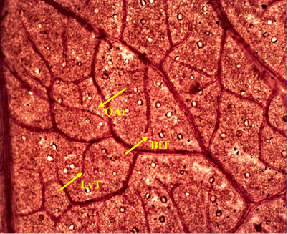
Figure 1 Adaxial Surface ×4 Venation: QAr (Quadrangular areole), LvT (Linear vein termination), BfT ( Bi-forked termination)

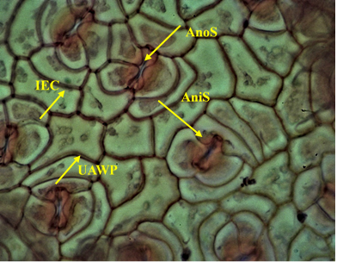
Figure 2: Abaxial surface ×4; AnoS (Anomocytic stomata); AniS (Anisocytic stomata), UAWP (Undulate anticlinal wall pattern) IEC (Irregular epidermal cell)

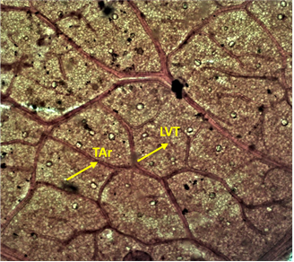

Figure3: Venation ×4: Tar (Triangular Areole), LVT (Linear Vein Termination)

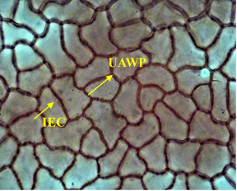
Figure 4: Adaxial Surface ×40: IEC (Irregular Epidermal Cell), UAWP (Undulate Anticlinal Wall Pattern

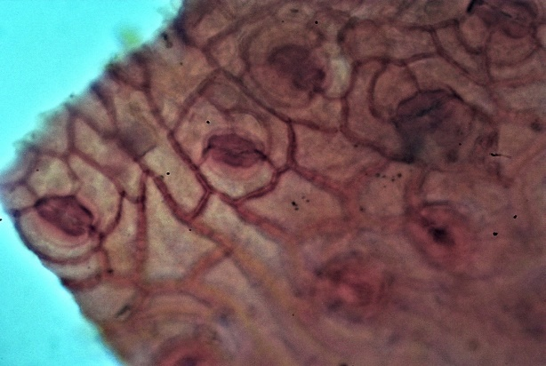
IEC
AnoS
AniS

Figure 5: Powder analysis of M. puberula leaf ×40: AnoS
(Anomocytic stomata), (Anisocytic stomata), IEC (Irreglar Epidermal Cell)

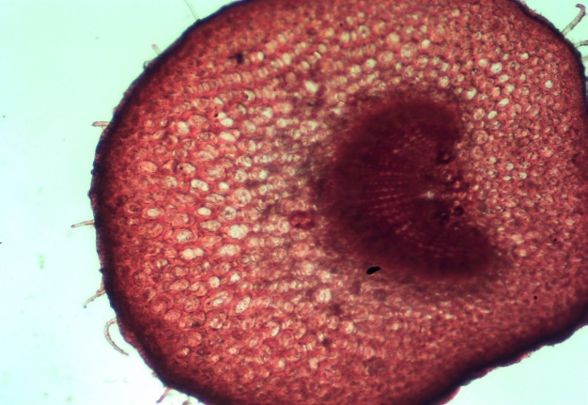
LE
UT
P
Co
Vb

Figure 6: Transverse section of Petiole ×40: LE (Lower Epidermis), UT (Unicellular Trichome), P (Parenchyma), Co (Collenchyma), Vb (Vascular bundle)

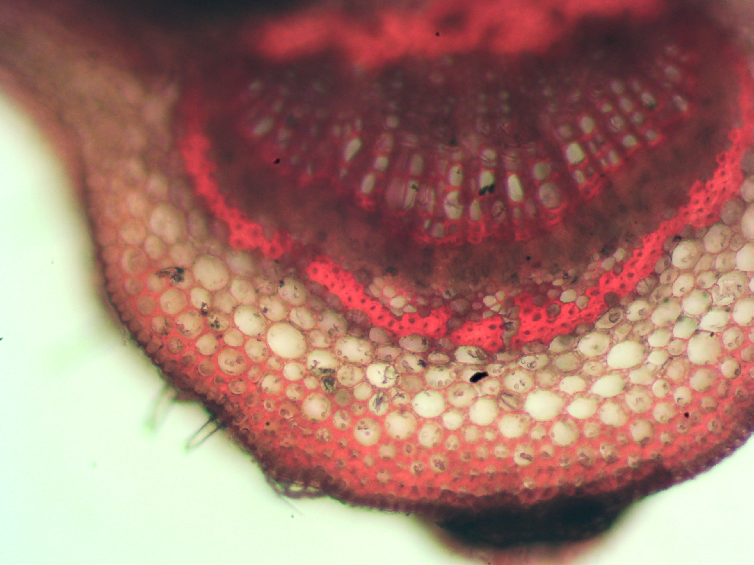
LE
Co
P
Ph
Xy
Vb

Figure 7: Transverse section of leaf ×40: Ph (Phloem), Xy (Xylem); Co (Collenchyma), Vb (Vascular bundle), LE (Lower Epidermis), P (Parenchyma)

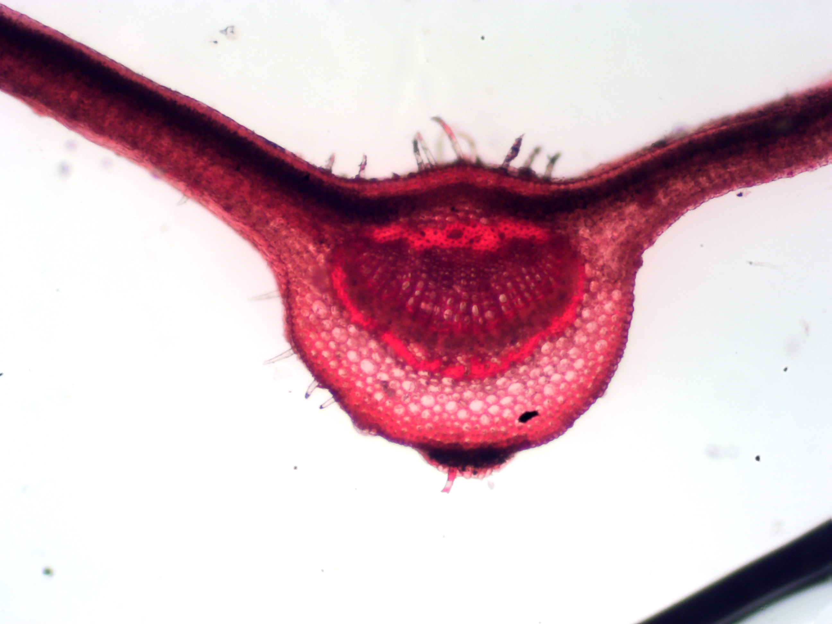
UE

Figure 8: Transverse section of leaf ×40; UE (Upper Epidermis)

Table 2 Showing Micromeritic evaluation of M. puberula Powdered Leaf and Stem
Micromeritic Parameters | Leaf Powder | Stem Powder
Bulk Volume (mL) | 36.83±0.61 | 37.16±0.16
Tapped Volume (mL) | 23.66±0.33 | 28.66±0.33
Bulk density (g/mL) | 2.27±0.00 | 0.26±0.00
Tapped density (g/mL) | 0.42±0.00 | 0.34±0.00
Hausner ratio | 1.55±0.02 | 1.29±0.01
Carr’s Index (%) | 35.76±1.03 | 22.84±0.82
Diameter of Heap (cm) | 7.04±0.02 | 7-67±0.13
Height of Heap (cm) | 2.91±0.01 | 2.83±0.03
Flow Time (sec) | 36.33±0.66 | 51.66±0.88
Angle of Repose (⁰) | 39.61±0.61 | 36.41±0.22
Results presented as Mean±SEM of Three (3) Replicates

Table 3: Showing Chemomicroscopic Evaluation of Leaf and Stem of M. puberula Powder
Parameters | Leaf | Stem
Cellulose | + | +
Lignin | - | +
Starch | + | +
Oil | + | +
Calcium oxalate | - | -
Muscilage  Protein | +  _ | +  -

+ = Present, - = Absent

Table 4: Showing Physicochemical constants of leaf and stem of M. puberula

Parameters | Weight(g) | Leaf (% ^{w}/_{w}) | Weight(g) | Stem (% ^{w}/_{w})
Moisture content | 0.3175 | 10.58 | 0.3113 | 10.38
Total ash | 0.1663±0.00 | 5.54 | 0.0790±0.00 | 2.63
Water-Soluble Ash | 0.0396 | 1.32 | 0.0211 | 0.70
Water-Insoluble | 0.13±0.00 | 4.33 | 0.06±0.00 | 2.00
Acid-Soluble | 0.1055 | 3.52 | 0.0520 | 1.73
Acid-Insoluble | 0.0575±0.00 | 1.92 | 0.025±0.00 | 0.83
Data are presented as mean ± standard error in triplicate

Table 5: Showing Water-soluble, Ethanol-soluble and Methanol-soluble Extractive Values of leaf and stem of M. puberula
Parameters | Gram weight(g) | Leaf (% ^{w}/_{w}) | Gram weight(g) | Stem (% ^{w}/_{w})
Water-Soluble | 0.6224 | 15.56 | 0.2624 | 6.56
Ethanol-Soluble | 0.13±0.002 | 13.00 | 0.0456±0.002 | 4.56
Methanol-Soluble | 0.1289±0.003 | 12.89 | 0.0389±0.0011 | 3.99
Data are presented as mean ± standard error in nine replicates

Table 6: Showing Evaluation of Florescence Properties of M. puberula Leaf and Stem Extracts in various solvents under Ultra-Violet (UV) light
Extracts |  | Sample |  | Physical observation Colour |  | UV-365 nm
Hexane |  | Leaf  Stem |  | Green  Colourless |  | Light orange  Light ash
Dichloromethane |  | Leaf  Stem |  | Light green  Colourless |  | Deep orange  Light brown
Ethanol |  | Leaf  Stem |  | Light brown  Colourless |  | Deep orange  Light yellow
Methanol |  | Leaf  Stem |  | Deep green  Colourless |  | Deep orange  Light yellow
Water |  | Leaf  Stem |  | Light brown  Colourless |  | Deep ash  Deep ash
Ethylacetate |  | Leaf  Stem |  | Light brown  Colourless |  | Yellow  Deep ash

4. DISCUSSION
The pharmacognostic parameters are reliable and inexpensive criteria for confirmation of the identity of crude drugs [11, 12].The results obtained for the adaxial and abaxial surfaces were undulate epidermal cell wall pattern, hypostomatic distribution of stomata and areole were present. Anomocytic and anisocytic type of stomata and guard cells were present in the abaxial surface. The transverse section of the leaf and petiole showed epidermis, collenchyma and vascular bundles. Phloem and xylem were present in the transverse section of the leaf while unicellular trichome and parenchyma were present in the transverse section of the petiole (Figure 1-8). The quantitative leaf microscopy revealed the average stomatal frequency (stomatal number) of 90.7 ± 0.68 and stomatal index 15.1 %. The epidermal layer was longer in abaxial surface 26.44 ± 0.08 than adaxial surface 24.43 ± 0.08, thickness of epidermal wall was 2.57 ± 0.04 on adaxial surface and 2.04±0.14 on the abaxial surface (Table 1). The micromeritic evaluation of powdered drug, the bulk and tapped volume, bulk and tapped densities of the leaf and stem of M. puberula were determined to be 36.83 ± 0.61 and 23.66 ± 0.33 mL, 37.16 ± 0.16 and 28.66 ± 0.33 mL, 2.27 ± 0.00 and 0.42 ± 0.00 g/mL, 0.26 ± 0.00 and 0.34 ± 0.00 g/mL respectively as shown in Table 2. Subsequently, Hausner ratio and Carr’s index for the leaf and stem were 1.55 ± 0.02 and 35.76 ± 1.03 %, 1.29 ± 0.01 and 22.84 ± 0.82 % respectively as presented in Table 2. The Hausner ratio and Carr’s index are parameters that are used to determine the powder flow property and powder characteristics. Hausner ratio values less than 1.25 (20 % Carr’s index) indicate good flow while those greater than 1.25 (33 % Carr’s index) indicates poor flow. From the result of the experiment, Hausner ratio and Carr’s index of the leaf are greater than 1.25% and 25 %, this indicate that the leaf powder has a poor flow property while the Hausner ratio and Carr’s index of the stem is less than 1.25% and 25 %, this indicate that the stem powder has a better flow property as shown in Table 2. Test to evaluate the flowability of powder include Carr’s compressibility index, Hausner ratio and angle of repose (Ø). Carr’s compressibility index shows the relationship between powder flowability and percentage compressibility. Angle of repose is a characteristic related to inter-particulate friction or resistance to movement between particles [14]. The rougher the surface of the particles, the higher the resistance (angle of repose) resulting in poor flow. Some factors that affect powder’s flowability and characteristics include particle size and surface force, particle shape (texture), moisture content, temperature and the time of storage at rest. There is a certain particle size at which powder flowability is optimum. Coarse particles are more preferred than fine ones as they are less cohesive. Alteration of the particle size distribution can also improve flowability. Particle shape (texture) also affects flowability. Spherical particles have better flow properties than more irregular particles. Particles with very rough surfaces are more cohesive and have a greater tendency to interlock than smooth surfaced particles. Moisture content of particle greatly affect powder’s flowability. Absorbed surface moisture films tend to increase bulk density and reduce porosity. Increase in temperature affects the sensitivity of some powders while others are sensitive at constant temperature. The flowability of the powder that remains at rest is difficult due to cohesiveness of the particles. The time of storage at rest also affects the flow of powder [15].The chemomicroscopic examination of the leaf and stem revealed the presence of cellulose, mucilage, oil and starch in the leaf and stem, protein and lignin in the stem while calcium oxalate was absent in both samples as shown in Table 3. Umoh et al (2020) also reported the presence of muscilage, lignin, calcium oxalate crystals, starch and oil in Gnetum africana Welw (Gnetaceae) [26]. Furthermore, the physicochemical constants analysis revealed the moisture content of leaf and stem of M. puberula to be 10.58% ^{w}/_{w} and 10.38 % ^{w/}_{w} respectively as stated in Table 4. The African pharmacopoeia limit of moisture content for vegetable crude drugs range between 8-14 % w/w with a few exceptions such as digitalis leaf with the value 6 % w/w. Therefore, the result of the research experiment showed the moisture content of M. puberula leaf and stem to be within the acceptable limit. This implies the crude drug cannot be stored for a long period to avoid microbial attack. High moisture content in crude drugs is uneconomical as it can lead to enzymatic activation through hydrolytic reaction and microbial growth (for example yeast and fungi). It can also lead to degradation of the active constituent of the drug [9]. The total ash value for M. puberula leaf and stem was 5.54% ^{w}/_{w} and 2.63 % ^{w}/_{w} respectively (Table 4). The European pharmacopoeia limit of total ash value for crude vegetable drugs range should not exceed 14 % ^{w}/_{w}. The result obtained from the experimental research showed that the total ash value of the leaf and stem of M. puberula was within the acceptable limit. The total ash value is a method used to measure the total residual substances that is not volatilized when the drug sample is incinerated. Ash contain inorganic salts of phosphates, carbonates and silicates of sodium, potassium, magnesium and calcium. Ash value is a criterion to judge the identity or purity of the crude drug. Ash may be derived from the plant itself and its usually called ‘physiologic ash’ or may come from extraneous matter, especially soil and sand that adhere to the surface of the drug and it is usually called ‘non-physiologic ash’. Generally, the amount of ash contained in a crude drug must be low as it also indicates to some extent the amount of care taken in the preparation of the drug [16]. The acid-insoluble ash value result of M. puberula leaf and stem were 1.92 ± 0.00 ^{w}/_{w} and 0.83 ± 0.00 % ^{w}/_{w} respectively (Table 4). The European pharmacopoeial limit of acid-insoluble ash value should not exceed 2 % ^{w}/_{w} [17]. Acid-insoluble ash value for the leaf of Justicia secunda Vahl. (Acanthaceae) 2 % ^{w}/_{w} and 1 % ^{w}/_{w} for stem has been reported [27]. Acid-insoluble ash value is used for the determination of earthy matter (siliceous materials like sand and stone) present on roots, rhizomes and leaves of crude drugs. The water-soluble ash value of M. puberula leaf and stem was determined to be 1.32 ± 0.00 and 0.70 ± 0.00 % ^{w}/_{w} as shown in Table 4. The water-soluble ash value shows the amount of crude drug soluble in distill water used. The water-insoluble ash value of M. puberula leaf and stem was determined to be 4.33 ± 0.00 and 2.00 ± 0.00 % ^{w}/_{w} as shown in Table 4. Water-insoluble ash is used to detect either crude drug is soluble in water or not. It is also used to estimate the amount of inorganic compound present in drugs [18]. The African pharmacopoeial limit for water-insoluble ash value for crude drugs states that a lesser amount shows that there is a less solubility of the ash in water while a higher value indicates a high solubility of the ash in water. The determination of the extractive value helps to evaluate the nature of phyto-constituent present in the drug and in the identification of exhausted or adulterated drug. It also helps in the quantification of phytoconstituents soluble in a particular solvent under the specified conditions [19]. The result of the experimental research showed that water-soluble, ethanol-soluble and methanol-soluble extractive values for the leaf and stem were 15.26 and 6.56% ^{w}/_{w}, 13.00% and 4.56% ^{w}/_{w}, 12.89 and 3.99 % ^{w}/_{w} respectively as depicted in Table 5. The constituent of M. puberula leaf was soluble in water, alcohol and methanol than the constituent of the stem. The highest solubility of the leaf constituent was observed in water (15.26 % ^{w}/_{w}) and ethanol (13.00 % ^{w}/_{w}). This finding corresponds with earlier research by Umoh et al (2022) who reported that water is the best solvent for the extraction of constituents of plants [25]. This implies that there were more water soluble constituents like inorganic compounds, acids and gums and alcohol soluble constituents like steroids, flavonoids, resinous materials, phenols and alkaloids in the leaf than the stem powder [20, 21]. The phyto-constituents in crude drug extractions is composed of varying amount of saponins, resins, alkaloids, terpenes, glycosides and carbohydrates. The composition of these bioactive constituent in an extraction depends on the nature of the crude drug and the type of solvent used [18]. These bioactive constituents have powerful pharmacological effects on humans and animals [22]. Saponins have been reported to have anti-cancer effect while flavonoids and phenols are natural source of antioxidants [23]. Alkaloids are the most abundant secondary metabolites found in plants and are claimed to have analgesic and antimicrobial properties [24].The result of fluorescence analysis of the M. puberula leaf and stem powder showed characteristic coloration upon treatment with different chemical solvents as depicted in Table 6. Florescence is an important phenomenon that shows different phyto-constituents present in crude drugs. Some of these constituents fluoresce in the visible range in daylight while others fluoresce with ultra-violet light. Crude drugs can be assessed qualitatively using fluorescence as it is important parameter in pharmacognostic studies [25].

5. CONCLUSION
This experimental research has evaluated the quality control parameters of this plant using WHO quality control profile and has provided some basis for the proper identification of M. puberula. The result collectively might also be useful to supplement information for further study of the plant.

ACKNOWLEDGEMENT
The authors would like to acknowledge the entire Laboratory staff of the Department of Pharmacognosy and Natural Medicine, Faculty of Pharmacy, University of Uyo for their assistance in making the research a success.

Conflict of Interest
Authors have declared that no conflict of interests exist.

Contribution of the Authors
This work was carried out in collaboration among all other authors. RAU and IIE designed the study, performed the experimental procedures, statistical analysis, IIE wrote the first draft of the manuscript. Authors RAU and IIJ supervised lab experiments. Authors IIJ, NAA and UFU, organized data, managed the literature searches, assisted in plant material preparation. All authors read and approved the final manuscript.

REFERENCES
[1] Zamble A, Yao D, Martin- Nizard F, Saphez S, Offoumou M, Duriez P, Brunet C, Bailleul F. Vasoactivity and antioxidant properties of M. keayana roots .Journal of Ethnopharmacology, 2006: 104: 263- 269.
[2] Neuwinger HD. African traditional Medicines: a dictionary of plant use and applications. Medpharm scientific, Stuttgart, Germany.2007. 589 p.
[3] Angiosperm Phylogeny Group (APG). An update of the angiosperm phylogeny group classification for the order and families of flowering plant APG IV. Botanical Journal of the plant Linnaean Society, 2016: 181(1): 1-20.
[4] Essiett UA, Archibong IA. The taxonomic significance of certain anatomical variation in four genera of Asteraceae. Bulletin of Environment, Pharmacology and Life Sciences, 2014: 3 (5): 150-163.
[5] Abubakar BY, Yunusa AI. Epidermal structure and stomatal ontogeny as an aid to the taxonomic identification of some species of Acacia from Nigeria .Nigerian Journal of Botany, 1998: 2: 117-123.
[6] Mbah C C, Builders PF, Akuodor GC, Kunle OO. Pharmaceutical characterization of Bridelia ferruginea Benth (Euphorbiaceae). Tropical Journal of Pharmaceutical Research, 2012: 11 (4): 637-644.
[7] Kokoski CJ, Kokoski RJ, Slama FJ. Fluorescence of powdered vegetable drugs with particular reference to development of ultraviolet light radiation.Journal of the American Pharmaceutical Association, 1958: 38: 715-719.
[8] Kokate CK, Purohit AP, Gokhale SB. Pharmacognosy. Nairali Prakashan, 4th edition. 2003: 109 (119): 121 -123.
[9] African Pharmacopoeia. General Method of Analysis. OAU/STRC Scientific Publication, Lagos, 1986: 3(1): 128-142.
[10] Khandelwal KR. Practical pharmacognosy techniqes and experiments. New Delhi, Nirali Prakashan, 2002: 15-163.
[11] WHO. Quality control methods for medicinal plant materials. World Health Organization. Geneva. 1992.
[12] Evans WC. Trease and Evans Pharmacognosy 115th edition. Elsevier, 2005. 20 p.
[13] Gupta MM, Srivastava B, Sharma M, Arya V. Spherical crystallization: A tool of particle engineering for making drug powder suitable for direct compression. International Journal of Pharmaceutical Research and Development, 2010: 1:1-10.
[14] Walter I. The Pharmaceutical Codex, principles and Pharmaceutics, 2009: 12:184-185.
[15] Marinelli, J. (2013). Factors that impact a powder flowability. https://www.powder bulksolids.com.
[16] Abere TA, Onwukaeme ND. Pharmacognostic evaluation of the leaf of Secamone afzelii (Schult) K. Schum. (Asclepiadaceae). Tropical Journal of Pharmaceutical Research, 2012: 11(1): 125-131.
[17] European Pharmacopoeia. Pharmacopoeia Limits of Crude drugs. Strasbourg: Council of Europe, 2007: 6: 124-164.
[18] Tatiya A, Surana S, Bhavsar S, Patil D, Patil Y. Pharmacognostic and preliminary phytochemical investigation of Eulophia herbaceae Lindl. Tubers (Orchidaceae). Asian Pacific Journal of Tropical Diseases, 2012: 2(1): S50-55.
[19] Ozarkar KR. Studies on anti-inflammatory effects of two herbs Cissus Quadrangularis Linn. and Valeriana wallichi DC using mouse model. Ph.D. Thesis, University of Mumbai, Mumbai. 2005.
[20] Shwetajain SC, Khatri P, Jain A, Vaidya A. Pharmacognostic and phytochemical investigations of the leaves of Zizyphus xylopyrus (Retz) Willd. International Journal of Pharmacy and Pharmaceutical Sciences, 2011: 3: 122-125.
[21] Kripa KG, Sangeetha R, Chamundeewari D. Pharmacognostical and physicochemical evaluation of the plant Leucas aspera. Asian Journal of Pharmaceutical and Clinical Research, 2016: 9: 263-268.
[22] Kam PC, Lie S. Traditional Chinese herbal medicine and anaesthesia. Anaesthesia, 2002: 57 (11): 1083-1089.
[23] Ali SS, Kasoju LA, Singh A, Sharanabasava H, Sahuand A. Indian medicinal herbs as a source of antioxidants. Food Research International, 2008: 41: 1-15.
[24] Alagar RM, Shailaja V, David B, Rao KNV, Selva-Kumar D. Evaluation of standardization parameters, pharmacognostic study, preliminary phytochemical screening and in vitro antidiabetic activity of Emblica officinalis fruits as per WHO guidelines. Journal of Pharmacognosy and Phytochemistry, 2014: 3(4):21-28.
[25] Umoh RA, Johnny II, Udoh AE, Andy NA, Essien A, Udoh IJ, Ekpo TE, Ashibeshi GU. Taxanomic and Pharmacognostic Evaluation of Leaf of Mussaenda phillippica (Rubiaceae). Asian Plant Research Journal, 2022: 9(1):6-13.
[26] Umoh RA, Umoh UF, Johnny II, Umoh OT, Anah VU, Udoh AE, Elijah AA, Adefabi MA, Matthew EA. Phytopharmacognostic Evaluation of the Leaves of Gnetum africanum Welw (Gnetaceae). Journal of Complementary and Alternative Medical Research, 2020: 11(3):32-41.
[27]Umoh RA, Johnny II, Umoh OT, Udoh AE, Anah VU, Obah-Eni LC. Pharmacognostic Evaluation of the Leaves and Stems of Justicia secunda Vahl. (Acanthaceae). World Journal of Pharmaceutical Research, 2020: 9(11):5-18.

